# Mother Duck

## High Concept:

Navigate a miniature diorama-style maze as you try to get to the goal with as many of your ducklings as possible

## Summary:

Navigate a grid-based maze of obstacles based around different settings as you attempt to get to the goal with all your ducklings intact. The ducklings line up in a trail behind extending behind you. As the mother you can move freely but the ducklings will attempt to follow you wherever you go. Don’t lead them to disaster!

As well as leading them through various obstacles you will also have a few items to help. What you have will depend on the level but might include an umbrella or cushion to help falls from great heights, or a stop sign to halt traffic.

## Genre/comparisons:

**Captain Toad Treasure Tracker / Monument Valley**

The basic controls for navigating a 3D puzzle box will be similar to Captain Toad Treasure Tracker on the Nintendo Switch or Monument Valley. The visual style will also take some inspiration from both, focusing on bright colours and a light tone with a stylistic edge.



Monument Valley

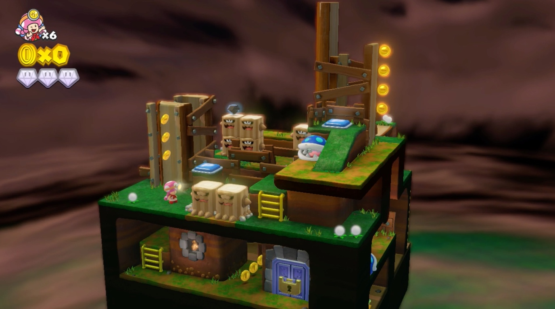

Captain Toad

**Lemmings**

The use of varied items to overcome certain puzzle challenges will be similar to the classic game Lemmings. You will receive a set number of certain items and will have to decide how you use them to get a perfect result. The ducklings will also be similar to the Lemmings in that a mistake or poor timing could see them all plummeting to their doom.

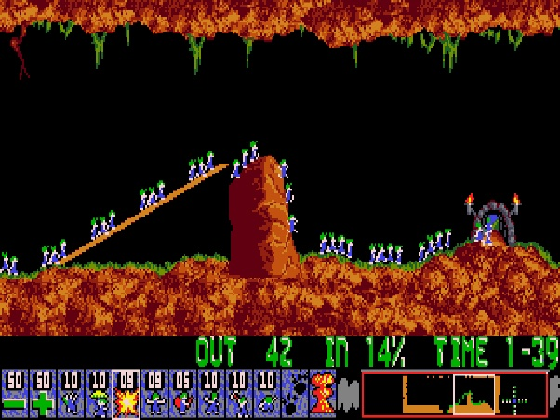

Lemmings

## Unique Selling Points (USPs)/features:

Whilst it will be easy to complete the basic puzzle, completing it without sacrificing any ducklings will prove extra challenging.

It takes a basic maze concept and adds an extra layer of complexity.

## Description of Game:

The game board is a diorama like maze where you can move in a grid. This could either be 2D from an isometric view or a 3D rotatable maze for more complexity. Movement can be controlled by either mouse or keyboard. An on-screen UI will allow the player to select different items to use on the play area.

The mother duck can get around easily. She can go straight to the goal with little trouble. The challenge is in keeping her children alive across the whole journey. The ducklings will attempt to follow her no matter what the situation, so you have to think twice before making any rash moves. In some situations, such as jumping from a large height, you will have a brief window of time before the ducklings feel brave enough to jump. You just have to make sure there is something there ready to catch them.

Gameplay is the deceptively simple task of getting the duck and ducklings from a to b. Obstacles will increase in difficulty with later levels combining them.

Possible obstacle examples:

A large height – solve by knocking something to make a ramp, or placing padding at the bottom, or a Lemmings style umbrella that allows them to float down.

A busy road – solved by timing your crossing or putting up a stop sign